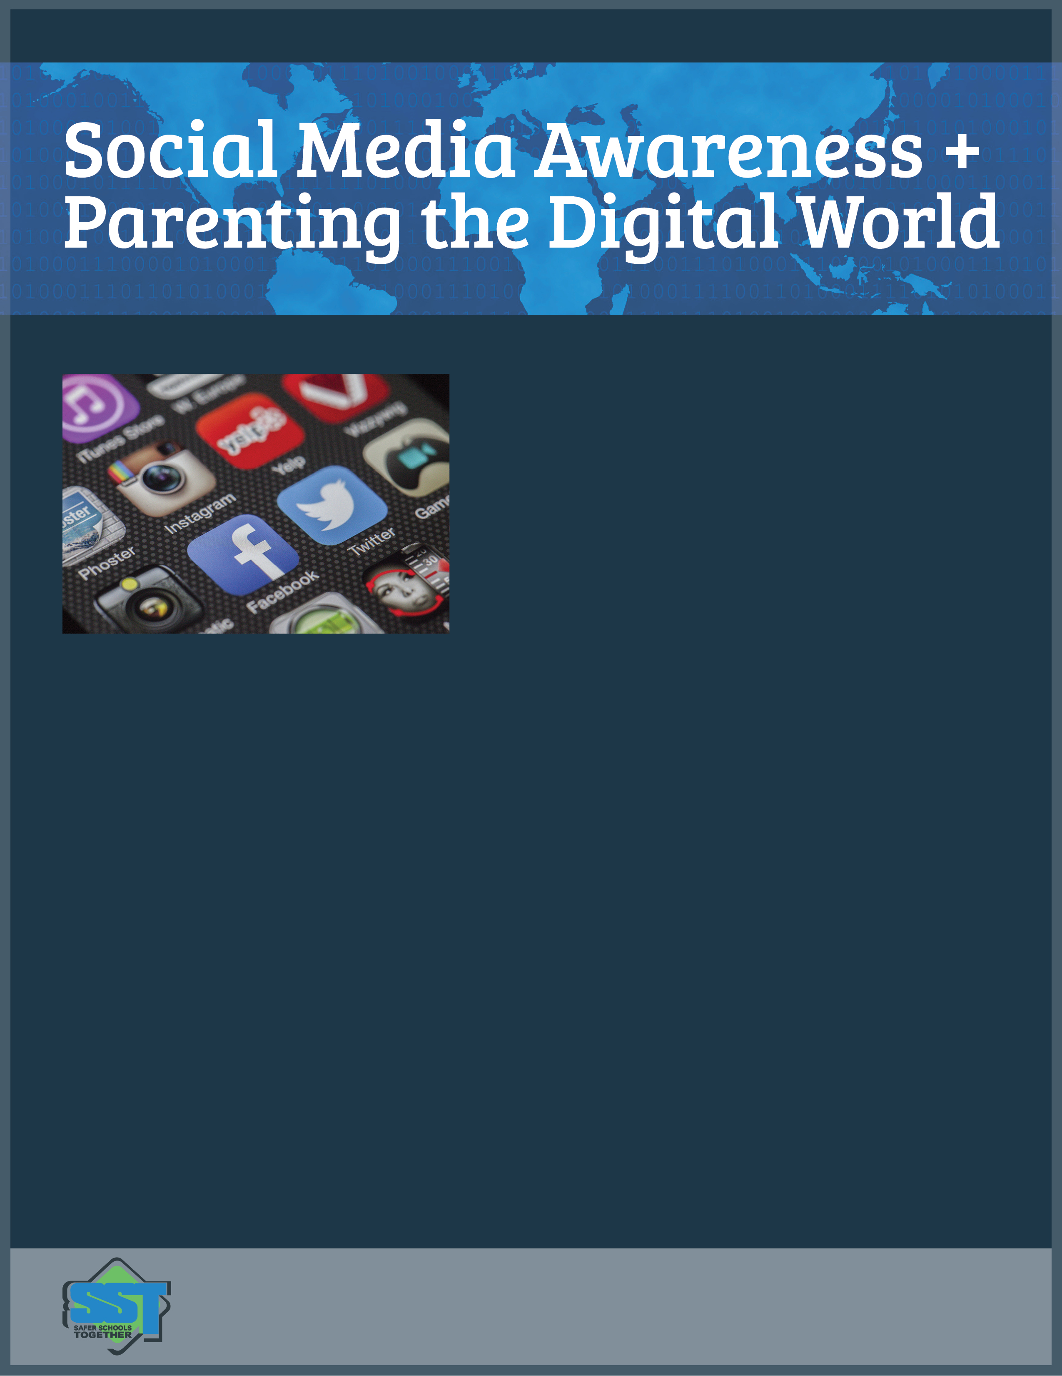

PARENTS: Do not miss this free event!

With society heading in a direction of being constantly connected to technology, what do we need to know as parents to protect our kids and teach them responsible and appropriate use of technology? The parameters of rules and expectations that you put in place at home will undoubtedly guide their behaviour in the years to come. Please join us for an informative presentation which will cover the following topics and more!

* **Social Media Update** – The most current apps & trends in their social media lives
* **Pick Your Battles! –** You will have to balance the yin with the yang, promote independence whilst taking a strong stance on certain subjects
* **Current Research** – Brain development & technology, violent video games
* **Digital Footprint and Reputation** – With their future approaching, recruiters and employers are taking note – What will they find? What will they leave behind?
* **Tips & Tricks to Use at Home**

**SSSAFER SCHOOLS TOGETHER**

is an organization focused on promoting a climate and culture of safety in schools through comprehensive education.

Please email **Ms. McKay**

**shmckay@sd43.bc.ca_**   
to RSVP and reserve your seat!

October 16, 2017  
7:00 pm  
Minnekhada Library

For parents of School aged  
children.